**Investment Summary: Air China Ltd (601111.SS)**

As of: 5 September 2025  
Stock Price (previous close): 7.55 CNY  
Market Cap: Approx. 119.78 billion CNY  
Industry: Airline (Flag Carrier)  
Recommended Action: Buy

**Business Overview**

Air China Ltd is the flag carrier and one of the largest airlines in China, providing passenger, cargo, and related air transportation services globally. It operates a wide network encompassing domestic and international routes, with a full-service model offering business and premium economy services alongside economy. In FY 2024, revenue was approximately RMB 166.7 billion with ongoing recovery from pandemic-related challenges. The airline serves a diverse customer base including business and leisure travelers, emphasizing safety, network breadth, and customer service excellence. Key strengths include strong government backing, strategic alliances (Star Alliance), and extensive route network. Challenges comprise high operating costs, volatile fuel prices, and intense competition domestically and internationally.

**Business Performance**

* Revenue grew from RMB 141.1 billion in 2023 to RMB 166.7 billion in 2024 (approx. 18% growth), and forecasted to reach RMB 177.36 billion in 2025.
* The company returned to profitability with estimated net income of RMB 3.95 billion for 2025 after losses in prior years.
* Operating cash flow improved significantly, aiding fleet renewals and operational expansions.
* Air China holds a leading domestic market share of ~20%, ranking among top Chinese carriers with a premium full-service model presence.

**Industry Context**

* The full-service airline industry is nearing maturity, with recovery phases evident post-pandemic.
* China aviation market is expected to grow at CAGR ~8%, driven by rising middle-class mobility and international travel resumption.
* Air China’s sales growth outpaces the industry averages while adapting to evolving customer preferences.
* Debt-to-total assets ratio remains high reflecting capital-intensive fleet investment, but manageable.
* Industry cycle is in a recovery/expansion phase following pandemic downturn.

**Financial Stability and Debt Levels**

Air China operates with stretched liquidity, showing a current ratio below 1 (around 0.38), reflecting tight short-term liquidity. The total debt remains considerable, with a debt-to-equity ratio notably higher than industry averages due to recent financial distress but improving. Interest coverage and operating cash flow highlight ongoing improvements, though financial leverage requires careful monitoring. The Altman Z score points to moderate bankruptcy risk, but strong government ties provide support.

**Key Financials and Valuation**

* FY 2024 Revenue: RMB 166.7 billion, YoY growth ~18%.
* Net Income (2025 estimate): RMB 3.95 billion, recovering from losses in previous years.
* P/E ratio (forward): ~27.2x, higher than sector average, reflecting growth expectations.
* Dividend yield currently low, given focus on recovery and capex.
* DCF fair value estimate approx. 7.86 CNY vs. current price 7.55 CNY, implying slight upside (~4.1%).
* Industry relevant metrics: Load factor near 80% (good operational efficiency), EBIT margin improving.

**Big Trends and Events**

* International travel rebounds underpin revenue growth.
* Increased fuel prices and labor costs pressure margins.
* Environmental regulation tightening impacts fleet strategy and costs.
* Strategic alliances and digital transformation enhance service offerings and operational efficiency.

**Customer Segments and Demand Trends**

* Major segments: Business travelers (~50%), leisure travelers (~40%), cargo (~10%).
* Sales growth forecast at ~7% CAGR supported by international travel reopening.
* Demand trends favor premium services; digital and personalized offerings growing in importance.

**Competitive Landscape**

* Highly competitive full-service carrier segment with Air China competing against China Southern and China Eastern.
* Strong government backing and Star Alliance membership constitute key moats.
* Scale advantages in fleet size and route network are critical competitive fronts.

**Risks and Anomalies**

* Liquidity constraints with a current ratio below industry norm.
* High leverage and refinancing risks in capital-intensive sector.
* Exposure to fuel price volatility and geopolitical tensions affecting international travel.
* Operational risks from complex international network.

**Forecast and Outlook**

* Management anticipates steady revenue and profit growth as travel recovers.
* Earnings expected to improve by 81.66% in 2026.
* Focus on cost discipline, fleet modernization, and service upgrades for competitive positioning.

**Leading Investment Firms and Views**

* Analysts largely positive with a consensus Buy rating; 15 analysts with price targets averaging 7.8 CNY.
* Recognized for strong recovery potential balanced with near-term leverage risks.

**Recommended Action: Buy**

Pros:

* Strong revenue recovery and return to profitability.
* Strategic government backing and alliance networks.
* Growth potential from expanding international travel.

Cons:

* High leverage and tight liquidity pose financial risks.
* Sector subject to fuel price volatility and geopolitical uncertainties.
* Elevated valuation relative to peers.

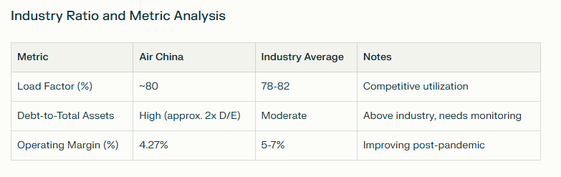

**Key Takeaways**

Air China is recovering strongly post-pandemic, with improving profitability and revenue growth underpinned by market share and alliance advantages. While financial stability concerns remain due to high leverage and liquidity constraints, government support and strategic positioning justify a Buy recommendation. Monitoring balance sheet improvements and fuel costs remains critical.

**Sources**

* [Air China Net Income and Financials - Eulerpool](https://eulerpool.com/en/stock/Air-China-Stock-CNE000001NN0/NetIncome)
* [DCF Valuation Summary - ValueInvesting.io](https://valueinvesting.io/601111.SS/valuation/dcf-growth-exit-5y)
* [Yahoo Finance - Air China](https://finance.yahoo.com/quote/601111.SS/)
* [DBS Bank report on Air China](https://www.dbs.com.sg/content/article/pdf/753_HK_EQUITY/2023/04/753_HK_EQUITY_57_12042023.pdf)
* [Reuters Company Profile](https://www.reuters.com/markets/companies/601111.SS/)